INTRODUCTION
SN360 special inverters are developed for the power supply of water pumps based on the core control algorithm of SN360 high performance inverters and the control requirements of PV water pumps.

All series products apply Infineon power modules. The function of Maximum power tracking, dormant at weak light, wake up at strong light, high water level dormant, underload pre-warning and other control protection functions can ensure normal operation of water pumps according to the customers’ requirements to switch to the grid power supply.

●Through adopting advanced MPPT technology ,this product can make full use of the efficiency of the solar cell array.

● It can automatically adjust the motor speed and the water flow along with the intensity of sunlight.

● Automatic sleep when on high-water level and automatic restart when on low-water level to realize automatic control through water level.

● Can prevent pump from anhydrous idling;

● It also can enter automatically to sleep mode when the intensity of sunlight is weak (e.g. The sunset.), as well as can exit the sleep mode when the intensity of sunlight is becoming strong (e.g. the sun rise.).

● Protect itself in trouble and improve the reliability of whole system.

Chapter 1 Inspections and safety precautions 1
1-1. Product specifications 1
1-2. Nameplate description 2
1-3. Model description 2
1-4. Technical Specification 3
1-4-1. SN360 Technical Specification 3
1-5. Wiring Digrams 5
1-5-1. Wiring Digrams below 11KW(3S1/3S2/2S3) 5
1-5-2.11KW~15KW wiring diagram(3N1) 6
1-5-3. Wiring diagram above 18.5KW(18.5-37kw) 7
1-6. Main circuit terminals 8
1-6-1. SN360 Main circuit terminals 8
1-6-2. Description of cabling terminal functions. 9
1-7. Control circuit terminals 9
1-7-1. Terminal arrangement of control circuit 9
1-7-2. Description of control circuit terminals 10
Chapter 2 Function Code Table 12
Group P00: Monitoring Parameters 13
Group P01: Basic Parameters 14
Group P02: Motor 1 Parameters 17
Group P04: V/F Control Parameters 18
Group P05: Input Terminals 19
Group P06: Output Terminals 22
Group P07: Start/Stop Control 24
Group P08: Operation panel and display 24
Group P09: Auxiliary Functions 25
Group P10: Fault and Protection 25
Group P15: Special functions for PV inverters 26
Group P17: Function code management 31
Group P23: Control Optimization Parameters 32
Chapter 3 Commissioning guide 33
INDICATE: 33
3-1.Wiring and commissioning steps 33
3-1-1.Commissioning steps during power supply 33
3-1-2.Commissioning steps during grid power supply 36
Chapter 4 Faults and Solutions 37
4-1. Fault Information and Troubleshooting 37
4-2. Common Faults and Solutions 42
Chapter 5 Recommended solar panels 45

Chapter 1 Inspections and safety precautions

1-1. Product specifications
Functions |  | specifications
Input | Input AC voltage (V) | AC380 3PH 380V(-15%)～440V(+10%)  AC220 Single phase 220V±15%,  AC220 3-phase 220V±15%,
Input | Maximum input DC bus voltage | 800VDC
Input | Recommended DC bus voltage | 540VDC
Input | Recommended MPPT range | 450~750VDC (380VAC)  260~350VDC (220VAC)
Input | Input current(A) | Refer to the rated value
Input | Input current(Hz) | 50Hz or 60Hz, Allowed range:47-63Hz
Output | Output voltage(V) | 0-the input voltage
Output | Output current(A) | Refer to the rated value
Output | Output power(kw) | Refer to the rated value
Output | Output frequency(Hz) | 0～300Hz
Control | Control mode | SVPWM,SVC
Control | Motor type | Asynchronous motor
Control | Speed ratio | Asynchronous motor 1:100(SVC)
Control | Speed control accuracy | ±0.2%(SVC)
Control | Speed fluctuation | ±0.3%(SVC)
Control | Torque response | <20ms(SVC)
Control | Torque control accuracy | 10%(SVC)
Control | Starting torque | 0.25Hz/150%(SVC)
Control | Overload capability | 150% of rated current:1 minute  180% of rated current:10 seconds  200% of rated current:1 second
Runnig  control | Frequency  setting method | Digital setting,  Analog setting,  Pulse frequency setting,  Multi-step speed running setting,  Simple PLC setting,  PID setting,MODBUS communication setting  Shift between the set combination and set channel
Runnig  control | Auto-adjustment of the voltage | Keep a stable voltage automatically when the grid voltage transients
Runnig  control | Fault protection | Provide over 30 fault protection functions:  Overcurrent,overvoltage,undervoltage,  Overheating,phase loss and overload.etc.
Runnig  control | Special functions for PV water pumps | Maximum power tracking,pre-warning at weak light(A-LS),auto wake up at strong light,  Pre-warning when full water(A-tF),auto wake up at low water level,  Underload pre-warning(A-LL) and fault protection of water level sensor (tSF),  When pre-warning, the inverter is in stand-by.
Peripheral interface | Terminal analog input resolution | ≤20mV
Peripheral interface | Terminal switch input resolution | ≤20ms
Peripheral interface | Analog input | Analog input 1 channel (AI1) 0～10V/0～20mA,  Analog input 1 channel (AI3) -10～10V
Peripheral interface | Analog output | Analog output 2 channels  (AO1、AO2) 0～10V/0～20mA
Peripheral interface | Digital input | 4 channels common inputs,the Max.frequency:1kHz,  Internal impedance 3.3KΩ；  1 channel high speed input,the Max.frequency:50kHz
Peripheral interface | Relay Output | 2 channels programmable relay output,  RO1A ON, RO1B NC, RO1C common terminal  RO2A ON, RO2B NC, RO2C common terminal  Contactor capability:3A/AC250V
Others | keyboard | External (≤30m)
Others | Mountable mode | Wall mountable and flange mountable
Others | Temperature of the running environment | -10～50℃,derate above 40℃
Others | Average non-fault time | 2 years (25℃ ambient temperature )
Others | Protective degree | IP20
Others | cooling | Air-cooling
Others | Braking unit | embedded(≤15KW)
 | EMC filter | Build-in C3 filter:meet the requires of IEC61800-3 C3  External filte:meet the requires of IEC61800-3 C2

1-2. Nameplate description
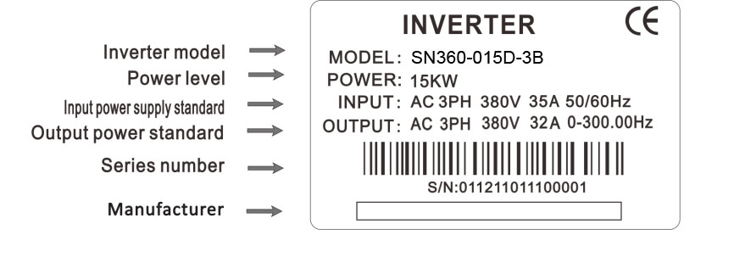
Pic 1-1 Nameplate description

1-3. Model description
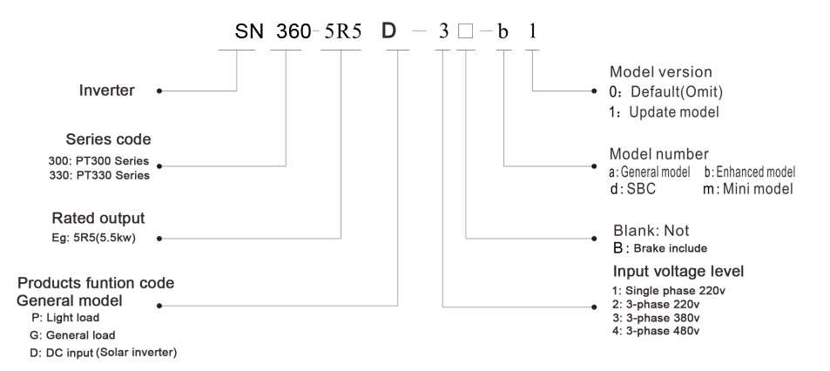
Pic 1-2 Model description

1-4. Technical Specification

1-4-1. SN360 Technical Specification
Model | DC/AC  Input voltage | Rated output  Power(KW) | Rated input  current(A) | Rated output  current(A) | Adaptable  motor
SN360-0R4D-1B | DC input:  200-350vdc  AC input:  1-phase 220V±15% | 0.4 | 5.4 | 2.1 | 0.4
SN360-0R7D-1B | DC input:  200-350vdc  AC input:  1-phase 220V±15% | 0.75 | 8.2 | 4.0 | 0.75
SN360-1R5D-1B | DC input:  200-350vdc  AC input:  1-phase 220V±15% | 1.5 | 14.0 | 7.0 | 1.5
SN360-2R2D-1B | DC input:  200-350vdc  AC input:  1-phase 220V±15% | 2.2 | 23.0 | 9.6 | 2.2
SN360-004D-1B | DC input:  200-350vdc  AC input:  1-phase 220V±15% | 3.7 | 34.0 | 17.0 | 3.7
SN360-0R4D-2B | DC input:  200-350vdc  AC input:  3-phase 220V±15% | 0.4 | 3.4 | 2.1 | 0.4
SN360-0R7D-2B | DC input:  200-350vdc  AC input:  3-phase 220V±15% | 0.75 | 5.0 | 3.8 | 0.75
SN360-1R5D-2B | DC input:  200-350vdc  AC input:  3-phase 220V±15% | 1.5 | 9.2 | 7.0 | 1.5
SN360-2R2D-2B | DC input:  200-350vdc  AC input:  3-phase 220V±15% | 2.2 | 10.5 | 9.0 | 2.2
SN360-004D-2B | DC input:  200-350vdc  AC input:  3-phase 220V±15% | 3.7 | 14.6 | 13 | 3.7
SN360-5R5D-2B | DC input:  200-350vdc  AC input:  3-phase 220V±15% | 5.5 | 26.0 | 25 | 5.5
SN360-7R5D-2B | DC input:  200-350vdc  AC input:  3-phase 220V±15% | 7.5 | 35.0 | 32 | 7.5
SN360-011D-2 | DC input:  200-350vdc  AC input:  3-phase 220V±15% | 11.0 | 46.5 | 45 | 11.0
SN360-015D-2 | DC input:  200-350vdc  AC input:  3-phase 220V±15% | 15.0 | 62.0 | 60 | 15.0
SN360-018D-2 | DC input:  200-350vdc  AC input:  3-phase 220V±15% | 18.5 | 76.0 | 75 | 18.5
SN360-0R7D-3B | DC input:  400-750vdc  AC input:  3-phase 380V±15% | 0.75 | 3.4 | 2.1 | 0.75
SN360-1R5D-3B | DC input:  400-750vdc  AC input:  3-phase 380V±15% | 1.5 | 5.0 | 3.8 | 1.5
SN360-2R2D-3B | DC input:  400-750vdc  AC input:  3-phase 380V±15% | 2.2 | 5.8 | 5.1 | 2.2
SN360-003D-3B | DC input:  400-750vdc  AC input:  3-phase 380V±15% | 3.0 | 7.9 | 7 | 3.0
SN360-004D-3B | DC input:  400-750vdc  AC input:  3-phase 380V±15% | 3.7 | 10.5 | 9.0 | 3.7
SN360-5R5D-3B | DC input:  400-750vdc  AC input:  3-phase 380V±15% | 5.5 | 14.6 | 13 | 5.5
SN360-7R5D-3B | DC input:  400-750vdc  AC input:  3-phase 380V±15% | 7.5 | 20.5 | 17 | 7.5
SN360-011D-3B | DC input:  400-750vdc  AC input:  3-phase 380V±15% | 11 | 26 | 25 | 11
SN360-015D-3B | DC input:  400-750vdc  AC input:  3-phase 380V±15% | 15 | 35 | 32 | 15
SN360-018D-3 | DC input:  400-750vdc  AC input:  3-phase 380V±15% | 18.5 | 38.5 | 37 | 18.5
SN360-022D-3 | DC input:  400-750vdc  AC input:  3-phase 380V±15% | 22 | 46.5 | 45 | 22
SN360-030D-3 | DC input:  400-750vdc  AC input:  3-phase 380V±15% | 30 | 62 | 60 | 30
SN360-037D-3 | DC input:  400-750vdc  AC input:  3-phase 380V±15% | 37 | 76 | 75 | 37
SN360-0R7D-4B | DC input:  400-750vdc  AC input:  3-phase 480V±15%  DC input:  400-750vdc  AC input:  3-phase 480V±15% | 0.75 | 3.4 | 2.1 | 0.75
SN360-1R5D-4B |  | 1.5 | 5.0 | 3.8 | 1.5
SN360-2R2D-4B |  | 2.2 | 5.8 | 5.1 | 2.2
SN360-004D-4B |  | 3.7 | 10.5 | 9.0 | 3.7
SN360-5R5D-4B |  | 5.5 | 14.6 | 13 |  | 5.5
SN360-7R5D-4B |  | 7.5 | 20.5 | 17.0 |  | 7.5
SN360-011D-4B |  | 11.0 | 26.0 | 25.0 |  | 11.0
SN360-015D-4B |  | 15.0 | 35.0 | 32.0 |  | 15.0
SN360-018D-4 |  | 18.5 | 38.5 | 37.0 |  | 18.5
SN360-022D-4 |  | 22.0 | 46.5 | 45.0 |  | 22.0
SN360-030D-4 |  | 30.0 | 62.0 | 60.0 |  | 30.0
SN360-037D-4 |  | 37.0 | 76.0 | 75.0 |  | 37.0

1-5. Wiring Digrams
The inverter wiring includes main circuit and controlled circuit two parts. The user must be connecting wires right according to wiring diagram below.

1-5-1. Wiring Digrams below 11KW(3S1/3S2/2S3)

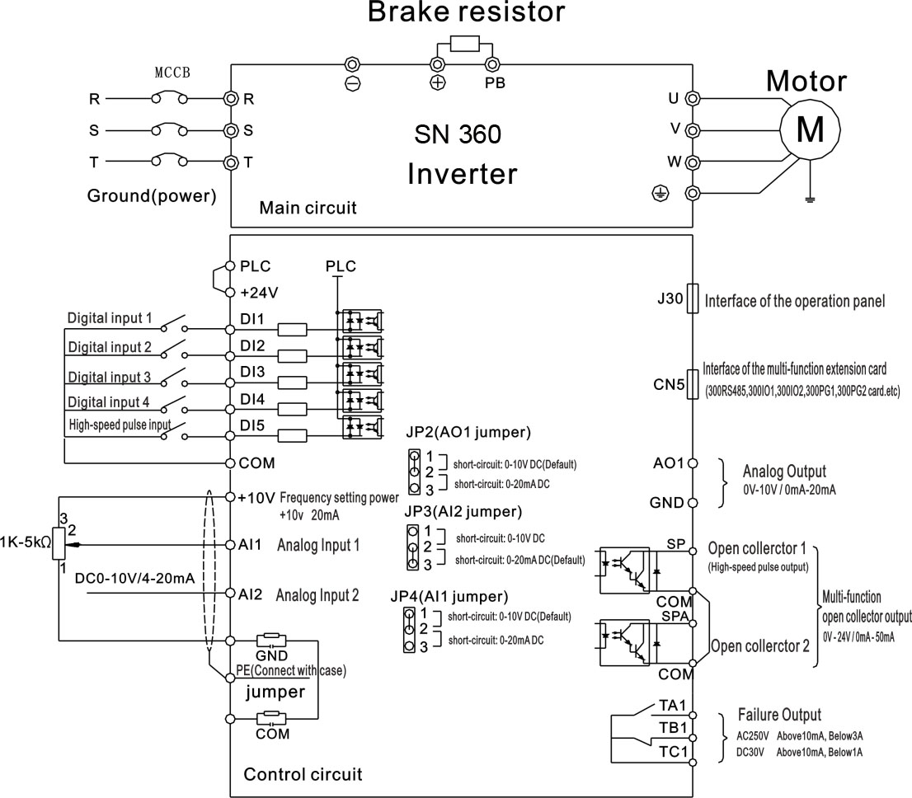

Pic 1-3 Wiring Diagrams below 11kw(3S1/3S2/2S3)

1-5-2.11KW~15KW wiring diagram(3N1)

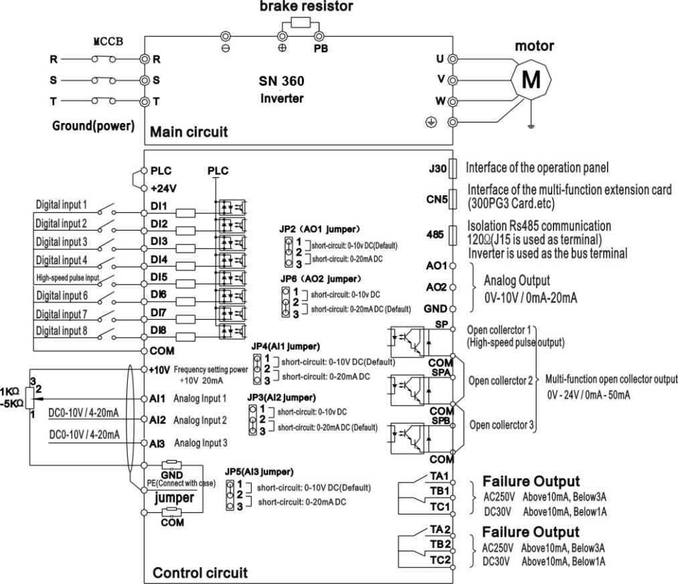

Pic 1-4. 11-15KW wiring diagram(3N1)

1-5-3. Wiring diagram above 18.5KW(18.5-37kw)

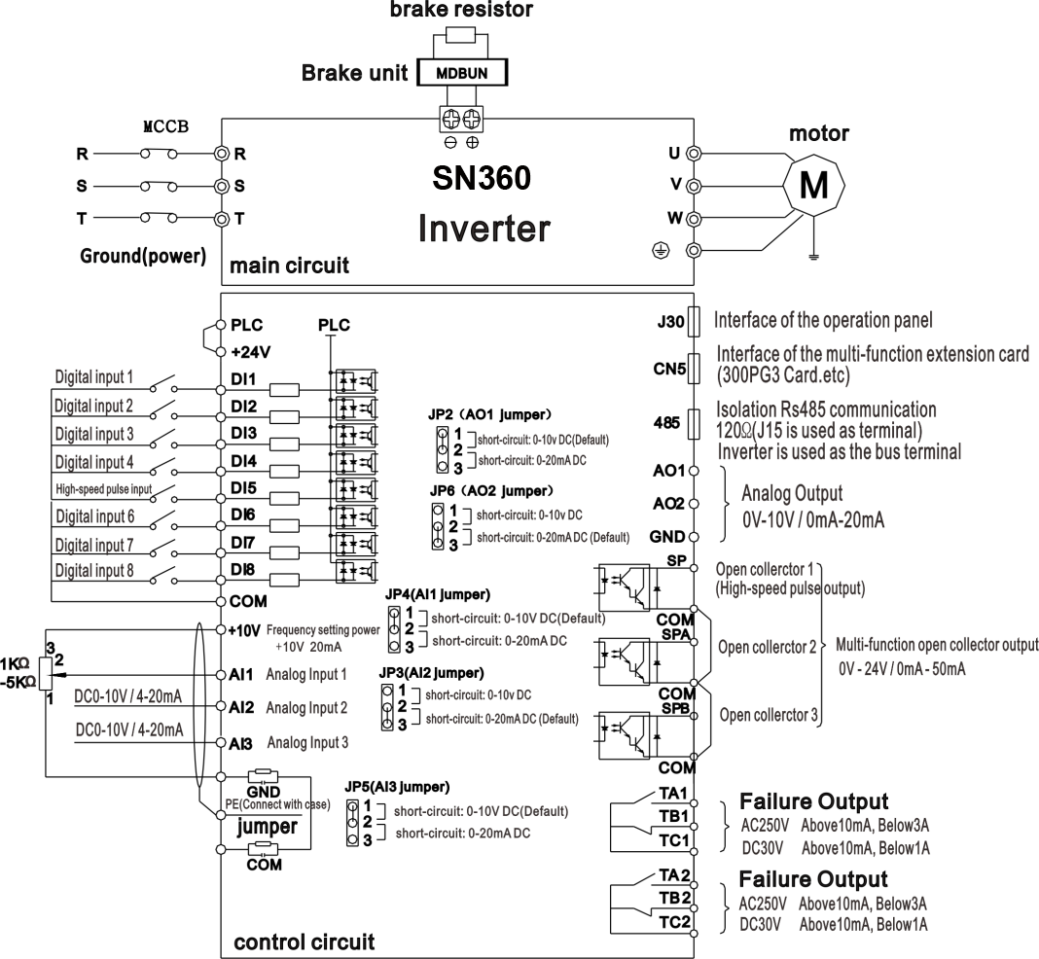

Pic1-5 Wiring diagram above 18.5KW(18.5-37kw)

1-6. Main circuit terminals

1-6-1. SN360 Main circuit terminals

1. SN360:Main circuit terminals below 15KW (380V)
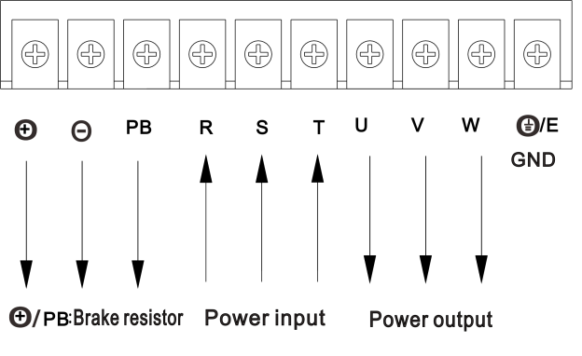

2. SN360:18.5KW～37KW(380V)Main circuit terminals
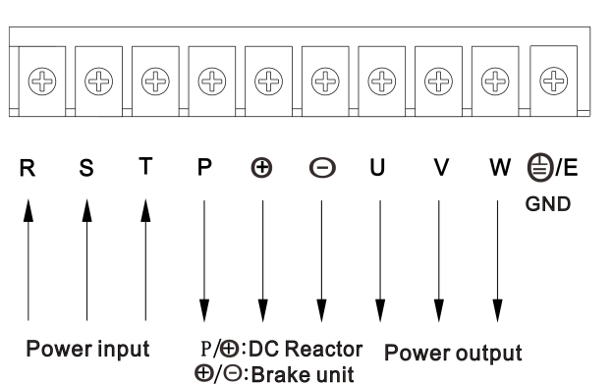

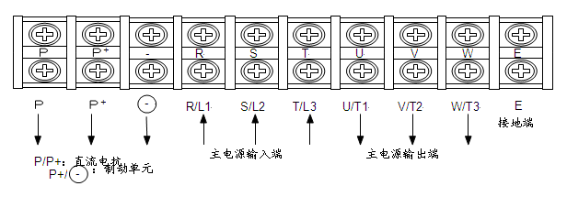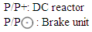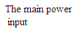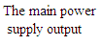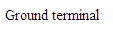3. PT300:30～37KW(380V)Main circuit terminals
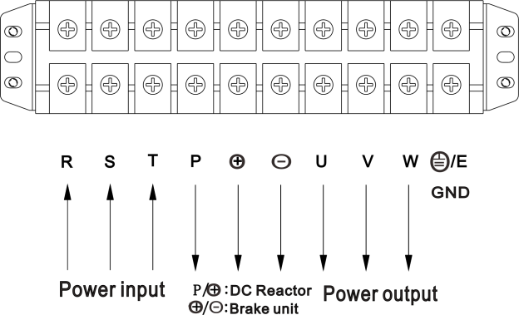

1-6-2. Description of cabling terminal functions.
Terminal | Name | Description
R/L1 | inverter power supply input terminals | Connect to 3-phase AC power supply ,and single phase AC power connect to L1,L2 terminal
S/L2 | inverter power supply input terminals
T/L3 | inverter power supply input terminals
/E | Grounding terminal | Connect to Ground.
U/T1 | inverter output terminals | Connect to a 3-phase motor
V/T2 | inverter output terminals | Connect to a 3-phase motor
W/T3 | inverter output terminals | Connect to a 3-phase motor
,PB/  | Connecting terminals of brake resistor or brake unit | Connect to the brake resistor or brake unit
P, | Connecting terminals of DC reactor | Connect to an DC reactor (Remove the short jumper bar )

1-7. Control circuit terminals

1-7-1. Terminal arrangement of control circuit

1. 300SCB control circuit terminals

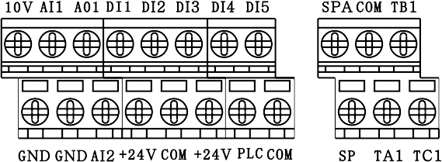

2. 300LCB control circuit terminals

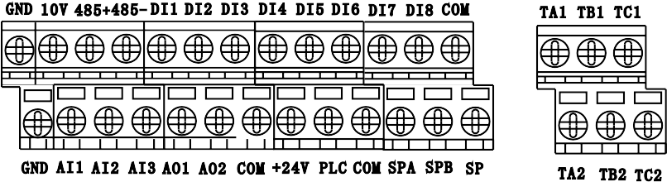

1-7-2. Description of control circuit terminals
Type | Terminal | Name | Function Description
Input signal | DI1～DI4  DI6～DI8 | DI1～DI4  DI6～DI8  Digital input terminal | 1.Optical coupling isolation,compatible with dual polarity input .  2.Impedance : 2.4KΩ.  3.Voltage range for level input: 9-30V.  Drain drive: PLC connects to 24V DC or external power.  Source drive:PLC connect to COM.
Input signal | DI5 | High-speed pulse  input terminal | Besides the features of DI1～DI4 and DI6～DI8,it can be used for high-speed pulse input.  Maximum input frequency is :100KHz.
Auxiliary power | +24V | Positive port of the power | Maximum output :+24V/200mA,in no conditions can short connect COM with GND.
Auxiliary power | COM | Common port
Output  signal | SPA/COM  SPB/COM | Digital output 1 | Optical coupling isolation, dual polarity open-collector output.  Input voltage range:0-24V.  Output current range:0-50mA.  (24V DC/150mA) COM is the common terminal,output function.
Output  signal | SP/COM | High-speed pulse  output terminal | It is limited by P06.00 “SP terminal output mode selection”,as high-speed pulse output ,the maximum frequency hits 100KHz.As open-collector output,its specification is the same as that of SPA and SPB.
Output  signal | TA1/TB1/TC1  TA2/TB2/TC2 | Output signal 3 | Contact driving capacity :  AC250V,3A,COSΦ=0.4  DC30V,1A  TA1→TC1 ON,TB1→TC1 NC.  TA2→TC2 ON,TB2→TC2 NC.
Analog  Input/  Output  signal | 10V→GND | Analog power | Provide 10V power supply to external unit,the maximum output current :10mA  It provide power supply to external potentiometer with resistance range of 1KΩ-5KΩ
Analog  Input/  Output  signal | AI1 | Multi-function analog input  signal 1 | 1. JP4 1-2 short circuit: 0- 10V input.  2. JP4 2-3 short circuit: 4- 20mA input.  3.Impedance :22kΩ(voltage input), 500Ω(current input)
Analog  Input/  Output  signal | AI2 | Multi-function analog input  signal 2 | 1. JP3 1-2 short circuit: 0- 10V input.  2. JP3 2-3 short circuit: 4- 20mA input.  3.Impedance :22kΩ(voltage input), 500Ω(current input)
Analog  Input/  Output  signal | AI3 | Multi-function analog input  signal 3 | 1. JP52 1-2 short circuit: 0- 10V input.  2. JP52 2-3 short circuit: 4- 20mA input.  3.Impedance: 22kΩ(voltage input), 500Ω(current input)
Analog  Input/  Output  signal | AO1,AO2 | Multi-function analog output signal | 1.JP2(AO1),JP41(AO2) 1-2 short circuit: 0- 10V.  2.JP2(AO1),JP41(AO2) 2-3 short circuit: 0- 20mA.
Auxiliary  interface | CN5 | Extension card interface | 38-pin terminal , Optical external extension card(300EX_CARD,300IO1,300IO2,300PLC1,300PG1,300PG2,300RS485 extension card ) interface .
Auxiliary  interface | J30 | Operation panel interface | Connect to internal /external operation panel interface.

Chapter 2 Function Code Table
Function of PT300 series Inverters can be divided into 30 groups, namely P00～P30 according to the function; and every function group includes several function codes. The function code adopts three-level menu; for example, P08.08 means the eighth function code in P08 function group ; and P16 is the manufacturer’s function parameter and the user has no right to visit the parameter in this group.
In order to make convenience for the setting of function code, group number of the function, number of function code and parameter of function code respectively corresponds with the first-level menu, the secondary menu and three-level menu when the operation panel is used for operation.
1. The content in the line of menu is as following:
The first line ”NUMBER”: it is the serial number for this function code in the whole function code; meanwhile, it also shows the register address for the communication.
The second line “CODE”: it is the serial number for the parameter group of the function and parameter.
The third line ”DESCRIBING LED/OLED KEYBOARD DISPLAY”: it is the detailed description of this function parameter.
The fourth line: “SETTING RANGE” : it is the effective setting range of the function parameter and it is shown on LED / OLED operation panel.
The fifth line ”FACTORY SETTING”: it is the original set value for the function parameter when it leaves the factory;(P00 group have not this parameter)
The sixth line “ALTERATION”: it is the alternative attributive of the function parameter (i.e. whether it allows alternation and alternating condition); and the inverter is as follow:
“◇” shows the set value of the parameter can be alternated whenever the Inverter is stopped or operated;
“□”shows the set value of the parameter can’t be alternated when the Inverter operated;
“■” shows the value of the parameter is actual record value of the detection; and it can’t be changed;
( the Inverter has made an automatic check and restriction on alternative attributive of every parameter and it can help the user to avoid wrong alternation.)
2. “Parameter system” is decimal system(DEC); if the parameter is shown via hexadecimal, every data is independent mutually when the parameter is edited; value range of partial bits can be hexadecimal (0～F).
3. “Factory setting” shows the value after the parameter of the function code is updated when the operation of recovering factory parameter; parameter or record value of actual detection can’t be updated.
4. In order to protect the parameter more effectively, the Inverter provides password protection for the function code. After the user password is set(namely, parameter for user password P07.00 is not 0) , the system will firstly enter into the state of user password authentication when the user press to enter into the editing state of the function code; and then what is shown is”-----” the operator must input user password correctly, or the user can’t enter. It is unnecessary to input manufacturer’s password correctly for the parameter zone set the manufacturer. (warning: the user can NOT try to change the parameter set by the manufacturer; if the parameter is not set properly, it will easily cause the abnormal work or even destroy of the Inverter). The user password can be changed randomly under the condition that the password protection is unlocked; the user password is subject to the value input last. Set P07.00 to 0 can cancel the user password; if P07.00 is not 0 when electrify, then it shows the parameter is protected by password.
- Function of user password also follows the above principle when the serial communication is used to change the parameter of the function code.

Group P00: Monitoring Parameters
Function Code | LED/OLED  Operation  panel display | Setting range | Factory settings | Modify
P00.00 | Running Frequency(Hz) | 0-300.00Hz | ■ | 7000
P00.01 | Set Frequency(Hz) | 0-300.00Hz | ■ | 7001
P00.02 | Bus Voltage (V) | 0-3000V | ■ | 7002
P00.03 | Output Voltage(V) | 0-1140V | ■ | 7003
P00.04 | Output Current(A) | 0-655.35A | ■ | 7004
P00.05 | Output Power(KW) | 0-32767KW | ■ | 7005
P00.06 | Output Torque(%) | -200.0%-200.0% | ■ | 7006
P00.07 | DI1-DI8 Input State | 0-32767 | ■ | 7007
P00.08 | SPA,SPB Output State | 0-1023 | ■ | 7008
P00.09 | AI1 Voltage(V) | 0-10.57V  0-20.000mA | ■ | 7009
P00.10 | AI2 Voltage(V) | 0-10.57V  0-20.000mA | ■ | 700A
P00.11 | AI3 Voltage(V) | 0-10.57V  0-20.000mA | ■ | 700B
P00.12 | Count Value | 0-65535 | ■ | 700C
P00.13 | Length Value | 0-65535 | ■ | 700D
P00.14 | Load Speed | 0-65535 | ■ | 700E
P00.15 | PID Setting | 0-100.0bar(kg) | ■ | 700F
P00.16 | PID Feedback | 0-100.0bar(kg) | ■ | 7010

Group P01: Basic Parameters
Function  Code | LED/OLED  Operation panel display | Setting range | Factory settings | Modify | Address
P01.00 | G/P type display | 1:G type(constant torque load )  2:P type (variable torque load e.g.fun and pump) | 1 | ■ | F000
P01.01 | Motor 1 control mode | 0:Sensorless Vector Control (SVC)  1:Closed-Loop Vector Control (FVC)  2:Voltage/Frequency Control (VF) | 2 | □ | F001
P01.02 | Command source selection | 0:operation panel control(LED OFF)  1:terminal control(LED ON)  2:communication control(LED blinking)  3:when power-on, Run automatically(LED OFF) | 0 | ◇ | F002
P01.03 | Main frequency source X selection | 0:Digital setting  (Preset Frequency is P01.08 UP/DOWN can be modified,non-retentive at power failure)  1:Digital setting  (Preset Frequency is P01.08, UP/DOWN can be modified,retentive at power failure)  2:Digital setting  (Preset Frequency is P01.08,non-retentive at power failure)  3:Digital setting  (Preset Frequency is P01.08, retentive at power failure)  4:AI1  5:AI2  6:AI3  7:Pulse setting(DI5)  8:Multi-reference  9:Simple PLC  10:PID  11:communication setting | 0 | □ | F003
P01.04 | Auxiliary frequency source Y selection | The same as P01.03  (Main frequency source X selection) | 0 | □ | F004
P01.05 | Range selection of auxiliary frequency Y for X and Y operation | 0:Relative to maximum frequency  1:Relative to main frequency X | 0 | ◇ | F005
P01.06 | Range of auxiliary frequency Y for X and Y operation | 0%～100% | 100% | ◇ | F006
P01.07 | Frequency source selection | Unit’s digit:Frequency source selection  0:Main frequency source X  1:X and Y operation  (operation relationship determined by ten’s digit)  2:Switchover between X and Y  3:Switchover between X and“X and Y operation”  4:Switchover between Y and“X and Y operation”  Ten’s digit:X and Y operation relationship  0:X+Y  1:X-Y  2:Maximum  3:Minimum | 00 | ◇ | F007
P01.08 | Preset frequency | 0.00Hz～Maximum frequency(P01.10) | 50.00Hz | ◇ | F008
P01.09 | Rotation direction | 0:Same direction  1:Reverse direction | 0 | ◇ | F009
P01.10 | Maximum frequency | 50.00Hz～300.00Hz | 50.00Hz | □ | F00A
P01.11 | Source of frequency upper limit | 0:Set by P01.12  1:AI1  2:AI2  3:AI3  4:Pulse setting  5:Communication setting | 0 | □ | F00B
P01.12 | Frequency upper limit | Frequency lower limitP01.14～Maximum frequency P01.10 | 50.00Hz | ◇ | F00C
P01.13 | Frequency upper limit offset | 0.00Hz～Maximum frequency P01.10 | 0.00Hz | ◇ | F00D
P01.14 | Frequency lower limit | 0.00Hz～Frequency upper limit P01.12 | 0.00Hz | ◇ | F00E
P01.15 | Carrier frequency | 0.5kHz～16.0kHz | Model dependent | ◇ | F00F
P01.16 | Carrier frequency adjustment with temperature | 0:No  1:Yes | 1 | ◇ | F010
P01.17 | Acceleration time 1 | 0.0s～6500.0s | Model dependent | ◇ | F011
P01.18 | Deceleration time 1 | 0.0s～6500.0s | Model dependent | ◇ | F012
P01.19 | Acceleration/Deceleration time unit | 0:1s  1:0.1s  2:0.01s | 1 | □ | F013
P01.20 | Power-on Auto run time delay setting | 0.0s~3600.0s | 10.0s | ◇ | F014
P01.21 | Frequency offset for auxiliary frequency source X and Y operation | 0.00Hz～maximum frequency P01.10 | 0.00Hz | ◇ | F015
P01.22 | Frequency reference resolution | 1:0.1Hz  2:0.01Hz | 2 | □ | F016
P01.23 | Stop memory selection of digital set frequency | 0:No memory  1:Memory | 1 | ◇ | F017
P01.24 | Motor selection | 0:Motor `1  1:Motor `2  2:Motor `3  3:Motor `4 | 0 | □ | F018
P01.25 | Acceleration/Deceleration time base frequency | 0:Maximum frequency(P01.10)  1:Set frequency  2:100Hz | 0 | □ | F019
P01.26 | Base frequency for UP/DOWN modification during running | 0:Running frequency  1:Set frequency | 0 | □ | F01A
P01.27 | Binding command source to frequency source | Unit’s digit :Binding operation panel command to frequency source  0:No binding  1:Frequency source by digital setting  2:AI1  3:AI2  4:AI3  5:Pulse setting(DI5)  6:Multi-reference  7:Simple PLC  8:PID  9:Communication setting  Ten’s digit:  Binding terminal command to frequency source  Hundred’s digit:  Binding communication command to frequency source  Thousand’s digit:  Binding auto-running to frequency source | 0000 | ◇ | F01B
P01.28 | Communication card type | 0:Modbus communication card  1:Profibus-DP communication card  2:CANopen communication card  3:CANlink communication card | 0 | ◇ | F01C

Group P02: Motor 1 Parameters
Function  Code | LED/OLED  Operation panel display | Setting range | Factory settings | Modify | Address
P02.00 | Motor type selection | 0:common asynchronous motor  1:variable frequency asynchronous motor  2:permanent magnetic synchronous motor | 0 | □ | F100
P02.01 | Rated motor power | 0.1KW～1000.0KW | Model dependent | □ | F101
P02.02 | Rated motor voltage | 1V～2000V | Model dependent | □ | F102
P02.03 | Rated motor current | 0.01A～655.35A  (inverter Power<=55KW)  0.1A～6553.5A  (inverter Power>55KW) | Model dependent | □ | F103
P02.04 | Rated motor frequency | 0.01Hz～Maximum  Frequency | Model dependent | □ | F104
P02.05 | Rated motor rotational speed | 1rpm～65535rpm | Model dependent | □ | F105
P02.06 | stator resistance  (asynchronous motor) | 0.001Ω～65.535Ω  (inverter Power<=55KW)  0.0001Ω～6.5535Ω  (inverter Power>55KW) | Tune  parameter | □ | F106
P02.07 | rotor resistance  (asynchronous motor) | 0.001Ω～65.535Ω  (inverter Power<=55KW)  0.0001Ω～6.5535Ω  (inverter Power>55KW) | Tune  parameter | □ | F107
P02.08 | leakage inductive  Reactance  (asynchronous motor) | 0.01mH～655.35mH  (inverter Power<=55KW)  0.001mH～65.535mH  (inverter Power>55KW) | Tune  parameter | □ | F108
P02.09 | mutual inductive  Reactance  (asynchronous motor) | 0.1mH～6553.5mH  (inverter Power<=55KW)  0.01mH～655.35mH  (inverter Power>55KW) | Tune  parameter | □ | F109
P02.10 | No load current  (asynchronous motor) | 0.01A～P02.03(inverter Power<=55KW)  0.1A～P02.03(inverter Power>55KW) | Tune  parameter | □ | F10A
P02.37 | Auto-turning selection | 0:No auto-turning  1:Asynchronous motor static auto-turning  2:Asynchronous motor complete auto-turning  11:Synchronous motor static auto-turning  12:Synchronous motor complete auto-turning | 0 | □ | F125

Group P04: V/F Control Parameters
Function  Code | LED/OLED  Operation panel display | Setting range | Factory settings | Modify | Address
P04.00 | VF curve setting | 0:Linear V/F  1:Multi-point V/F  2:Square V/F  3:1.2 power V/F  4:1.4 power V/F  6:1.6 power V/F  8:1.8 power V/F  9:Reserved  10:VF complete separation  11:VF half separation | 0 | □ | F300
P04.01 | Torque boost | 0.0%:(Automatic torque boost)  0.1%～30.0% | Model dependent | ◇ | F301
P04.02 | Cut-off frequency of torque boost | 0.00Hz～maximum frequency | 15.00Hz | □ | F302
P04.09 | VF slip compensation gain | 0.0%～200.0% | 0.0% | ◇ | F309
P04.10 | VF over-excitation gain | 0～200 | 64 | ◇ | F30A
P04.11 | VF oscillation suppressing gain | 0～100 | Model  dependent | ◇ | F30B

Group P05: Input Terminals
Function  Code | LED/OLED  Operation panel display | Setting range | Factory settings | Modify | Address
P05.00 | DI1 function selection | 0:No function  1:Forward run(FWD)  2:Reverse run(REV)  3:Three-line control  4:Forward JOG(FJOG)  5:Reverse JOG(RJOG)  6:Terminal UP  7:Terminal DOWN  8:Coast to stop  9:Fault reset(RESET)  10:Run Pause  11:Normally open input of external fault  12:Multi-reference terminal 1  13:Multi-reference terminal 2  14:Multi-reference terminal 3  15:Multi-reference terminal 4  16:Acceleration/Deceleration time selection terminal 1  17:Acceleration/Deceleration time selection terminal 2  18:Frequency source switchover  19:UP/DOWN setting clear  (terminal\operation panel)  20:Command source switchover terminal  21:Acceleration/Deceleration prohibited  22:PID pause  23:PLC status reset  24:Swing pause  25:Counter input  26:Counter reset  27:Length count input  28:Length reset  29:Torque control prohibited  30:Pulse frequency input  (only valid for DI5)  31:Reserved  32:Immediate DC braking  33:Normally closed input of external fault  34:Frequency modification enable  35:Reverse PID action direction  36:External stop terminal 1  37:Command source switchover terminal 2  38:PID integral pause  39:Switchover between main frequency source X and preset frequency  40:Switchover between main frequency source Y and preset frequency  41:Motor selection terminal 1  42:Motor selection terminal 2  43:PID parameter switchover  44:User-defined fault 1  45:User-defined fault 2  46:speed control/ torque control Switchover  47:Emergency stop  48:External stop terminal 2  49:Deceleration DC braking  50:Clear the current running time  51:Forced to run the terminal when below undervoltage point  52:Deceleration stop function, but Jog effective  53: PV Enable disable  54: PV Voltage given enable  55: PV Input and working frequency power supply switching | 1 | □ | F400
P05.01 | DI2 function selection |  | 2 | □ | F401
P05.02 | DI3 function selection |  | 8 | □ | F402
P05.03 | DI4 function selection |  | 9 | □ | F403
P05.04 | DI5 function selection |  | 12 | □ | F404
P05.05 | DI6 function selection |  | 13 | □ | F405
P05.06 | DI7 function selection |  | 0 | □ | F406
P05.07 | DI8 function selection |  | 0 | □ | F407
P05.08 | Reserved |  | 0 | □ | F408
P05.09 | Reserved | - | － | □ | F409
P05.10 | DI filter time | 0.000s～1.000s | 0.010s | ◇ | F40A
P05.11 | Terminal command mode | 0:two-line mode 1  1:two-line mode 2  2:three-line mode 1  3:three-line mode 2 | 0 | □ | F40B
P05.12 | Terminal UP/DOWN rate | 0.001Hz/s～65.535Hz/s | 1.00Hz/s | ◇ | F40C
P05.13 | AI curve 1 minimum input | 0.00V～P05.15 | 0.00V | ◇ | F40D
P05.14 | Corresponding setting of AI curve 1 minimum input | -100.0%～+100.0% | 0.0% | ◇ | F40E
P05.15 | AI curve 1 maximum input | P05.13～+10.00V | 10.00V | ◇ | F40F
P05.16 | Corresponding setting of AI curve 1 maximum input | -100.0%～+100.0% | 100.0% | ◇ | F410
P05.17 | AI1 filter time | 0.00s～10.00s | 0.10s | ◇ | F411
P05.18 | AI curve 2 minimum input | 0.00V～P05.20 | 0.00V | ◇ | F412
P05.19 | Corresponding setting of AI curve 2 minimum input | -100.0%～+100.0% | 0.0% | ◇ | F413
P05.20 | AI curve 2 maximum input | P05.18～+10.00V | 10.00V | ◇ | F414
P05.21 | Corresponding setting of AI curve 2 maximum input | -100.0%～+100.0% | 100.0% | ◇ | F415
P05.22 | AI2 filter time | 0.00s～10.00s | 0.10s | ◇ | F416
P05.23 | AI curve 3 minimum input | -10.00V～P05.25 | -10.00V | ◇ | F417
P05.24 | Corresponding setting of AI curve 3 minimum input | -100.0%～+100.0% | -100.0% | ◇ | F418
P05.25 | AI curve 3 maximum input | P05.23～+10.00V | 10.00V | ◇ | F419
P05.26 | Corresponding setting of AI curve 3 maximum input | -100.0%～+100.0% | 100.0% | ◇ | F41A
P05.27 | AI3 filter time | 0.00s～10.00s | 0.10s | ◇ | F41B
P05.34 | Setting for AI less than minimum input | Unit’s digit:Setting for AI1 less than minimum input  0:Minimum value  1:0.0%  Ten’s digit:Setting for AI2 less than minimum input,the same as AI1.  Hundred’s digit:Setting for AI3 less than minimum input,the same as AI1. | 000 | ◇ | F422

Group P06: Output Terminals
Function  Code | LED/OLED  Operation panel display | Setting range | Factory settings | Modify | Address
P06.00 | SP terminal output mode | 0:Pulse output(SPP)  1:Switch signal output(SPR) | 0 | ◇ | F500
P06.01 | SPR function | 0:No output  1:inverter running  2:Fault output(stop)  3:Frequency-lever detection FDT1 output  4:Frequency reached  5:Zero speed running(No output at stop)  6:Motor overload pre-warning  7:inverter overload pre-warning  8:Set count value reached  9:Designated count value reached  10:Length reached  11:PLC cycle complete  12:Accumulative running time reached  13:Frequency limited  14:Torque limited  15:Ready for run  16:AI1>AI2  17:Frequency upper limit reached  18:Frequency lower limit reached  19:Under-voltage state output  20:Communication setting  21:Reserved  22:Reserved  23:Zero-speed running(Having output at stop)  24:Accumulative power-on time reached  25:Frequency-lever detection FDT2 output  26:Frequency 1 reached  27:Frequency 2 reached  28:Current 1 reached  29:Current 2 reached  30:Timing reached  31:AI1 input exceeded  32:Load becoming 0  33:Reverse running  34:Zero current state  35:Module temperature reached  36:output current exceeded  37:Frequency lower limit reached(Having output at stop)  38:Alarm output(inverter continue to run)  39:Motor overheat pre-warning  40:Current running time reached  41: Fault output (Fault Stop)  42: PV working frequency input switching threshold reached (threshold judgment)  43: PV working frequency input switching (S input determination)  44: The light is weak | 0 | ◇ | F501
P06.02 | Relay function  (TA1-TB1-TC1)  Relay function  (TA1-TB1-TC1) |  | 2 | ◇ | F502
P06.03 | Extension card relay function  (TA2-TB2-TC2) |  | 0 | ◇ | F503
P06.04 | SPA function selection |  | 1 | ◇ | F504
P06.06 | SPP function selection | 0:Running frequency  1:Set frequency  2:Output current  3:Output torque  4:Output power  5:Output voltage  6:Pulse input  (100.% corresponds to 100.0KHz)  7:AI1  8:AI2  9:AI3(Extension card)  10:Length  11:Count value  12:Communication setting  13:Motor rotational speed  14:Output current(100.0% corresponds to 1000.0A)  15:Output voltage  (100.0% corresponds to 1000.0V)  16:Reserved | 0 | ◇ | F506
P06.07 | AO1 function selection |  | 0 | ◇ | F507
P06.09 | Maximum SPP output frequency | 0.01KHz～100.00KHz | 50.00KHz | ◇ | F509
P06.11 | AO1 gain | -10.00～+10.00 | 1.00 | ◇ | F50B
P06.13 | Extension card AO2 gain | -10.00～+10.00 | 1.00 | ◇ | F50D
P06.18 | TA1-TB1-TC1output relay time | 0.0s～3600.0s | 0.0s | ◇ | F512
P06.19 | TA2-TB2-TC2 output relay time | 0.0s～3600.0s | 0.0s | ◇ | F513

Group P07: Start/Stop Control
Function  Code | LED/OLED  Operation panel display | Setting range | Factory settings | Modify | Address
P07.03 | Start-up frequency | 0.00Hz～10.00Hz | 0.00Hz | ◇ | F603
P07.10 | Stop mode | 0:Deceleration to stop  1:Coast to stop | 0 | ◇ | F60A

Group P08: Operation panel and display
Function  Code | LED/OLED  Operation panel display | Setting range | Factory settings | Modify | Address
P08.00 | MF key function selection | 0:MF key disabled  1:Switchover between operation panel and remote command control(terminal or communication)  2:Switchover between forward rotation and reverse rotation  3:Forward JOG  4:Reverse JOG | 3 | □ | F700
P08.01 | STOP/RESET key function | 0:STOP/RESET key enable only in operation panel control  1:STOP/RESET key enable in any operation mode | 1 | ◇ | F701

Group P09: Auxiliary Functions
Function  Code | LED/OLED  Operation panel display | Setting range | Factory settings | Modify | Address
P09.00 | JOG running frequency | 0.00Hz～Maximum frequency | 2.00Hz | ◇ | F800
P09.01 | JOG acceleration time | 0.0s～6500.0s | 20.0s | ◇ | F801
P09.02 | JOG deceleration time | 0.0s～6500.0s | 20.0s | ◇ | F802
P09.14 | Running mode when set frequency lower than frequency lower limit | 0:Run at frequency lower limit  1:Stop  2:Run at zero speed | 0 | ◇ | F80E
P09.18 | Start-up protection | 0: NO  1: YES | 0 | ◇ | F812

Group P10: Fault and Protection
Function  Code | LED/OLED  Operation  panel display | Setting range | Factory settings | Modify | Address
P10.09 | Fault auto reset times | 0~20 | 0 | ◇ | F909
P10.45 | Forced to run low voltage enable | 0~1 | 1 | ◇ | F92D
P10.46 | Vector Zero-speed running output enable | 0~1 | 0 | ◇ | F92E
P10.59 | Action selection at instantaneous power failure | 0:Invalid  1:Deceleration  2:Deceleration to stop | 0 | ◇ | F93B
P10.60 | Instantaneous stop non-stop frequency switching point | 80.0%～100.0% | 100.0% | ◇ | F93C
P10.61 | Voltage rally judging time at instantaneous power failure | 0.00s～100.00s | 0.50s | ◇ | F93D
P10.62 | Action judging voltage at instantaneous power failure | 60.0%～100.0%(Standard bus voltage) | 80.0% | ◇ | F93E
P10.63 | protection of load lost | 0：Invalid  1：Valid | 1 | ◇ | F93F

Group P15: Special functions for PV inverters
Function  Code | LED/OLED  Operation panel display | Setting range | Factory settings | Modify | Address
P15.00 | PV inverter selection | 0:Invalid  1:Enable  0 means the function is invalid and the group of parameters can not be used  1 means the function enabled and P15 group parameters can be adjusted | 1 | ◇ | FE00
P15.01 | Vmpp voltage reference | 0:Voltage reference  1:Max.power tracking  0 means to apply voltage reference mode. The reference is a fixed value and given by P15.02.  1 means to apply the reference voltage of Max.power tracking.The voltage is changing until the system is stable.  No matter what kind of reference voltage is applied, if the bus voltage is higher than reference voltage, the target frequency will change to the upper limit of PI output frequency and if the bus voltage is lower than the reference voltage, the target frequency will change to the lower limit of PI output frequency.  Note:If terminal 54 is valid, the function is invalid. | 1 | ◇ | FE01
P15.02 | Vmpp voltage keyboard reference | 0.0～1000.0Vdc  If P15.01 is 0, the reference voltage is given by P15.02  For 380v motor as 530VDC(default)  For 220v motor as 260VDC(default) | 530.0V | ◇ | FE02
P15.03 | PI control deviation | 0.0～100.0%(100.0% corresponds to P15.02)  If the ratio percentage of bus voltage to reference voltage,which is abs(bus voltage-reference voltage)*100.0% / reference voltage, if the value exceeds the deviation limit of P15.03, PI adjustment is available, otherwise, there is no PI adjustment and the value is defaulted to be 0.0%  Abs: the absolute value | 0.0% | ◇ | FE03
P15.04 | Upper frequency of PI output | P15.05～100.0%(100.0% corresponds to P01.10)  P15.04 is used to limit the Max.value of target frequency, 100% corresponds to P01.10.  After PI adjustment, the target frequency can not exceed the upper limit. | 100.0% | ◇ | FE04
P15.05 | Lower frequency of PI output | 0.0%～P15.04(100.0% corresponds to P01.10)  P15.05 is used to limit the Min.value of target frequency,100% corresponds to P01.10.  After PI adjustment, the target frequency can not exceed the lower limit. | 20.0% | ◇ | FE05
P15.06 | KP1 | 0.00～100.00  The proportion coefficient 1 of the target frequency.  The bigger the value is the stronger the effect and faster the adjust is. | 20.00 | ◇ | FE06
P15.07 | KI1 | 0.00～100.00  The integral coefficient 1 of the target frequency.  The bigger the value is, the stronger the effect and faster the adjustment is. | 1.00 | ◇ | FE07
P15.08 | KP2 | 0.00～100.00  The proportion coefficient 2 of the target frequency.  The bigger the value is, the stronger the effect and the faster the adjustment is. | 40.00 | ◇ | FE08
P15.09 | KI2 | 0.00～100.00  The integral coefficient 2 of the target frequency.  The bigger the value is, the stronger the effect and faster the adjustment is. | 4.00 | ◇ | FE09
P15.10 | PI switching point | 0.0～6553.5Vdc  If the absolute value of bus voltage minus the reference value is bigger than P15.10,it will switch to P15.08 and P15.09: otherwise it is P15.06 and P15.07. | 50.0V | ◇ | FE0A
P15.11 | Water level control | 0:Invalid  1:AI1  2:AI2  3:AI3  The function is invalid if select 0.  1-3 is the reference from the simulating signal source of water level control.  After selecting the simulating signal source,P15.12,P15.13,P15.14 and P15.15 are valid. | 0 | ◇ | FE0B
P15.12 | Water level threshold | 0.0～100.0%  If the simulating signal is less than the water level threshold and keep in the state after the delay time set by P15.13, report A-tF and dormant.  If the time is not reached, the signal is bigger than the water level threshold, the time will be cleared automatically.  When the signal time is shorter than the water level threshold time, the time will be counted again. | 25.0% | ◇ | FE0C
P15.13 | Full water delay | 0～1000.0s  Time setting of full water delay | 6.0s | ◇ | FE0D
P15.14 | Non-water delay | 0～1000.0s  Time setting of non-water delay.  In the full water pre-warning,if the detected simulating signal is bigger than the value set by P15.12, it begins to count the delay time.  After lasting for the time set by P15.14, the pre-warning will be cleared.  Under the condition of non continuous, delay time will be reset automatically. | 60.0s | ◇ | FE0E
P15.15 | Hydraulic probe damage | 0.0～100.0%  0.0%:Invalid.  If it is not 0.0%, when the signal is longer than P15.15, it will report “E.tSF”fault directly and stop. | 0.0% | ◇ | FE0F
P15.16 | Operation time of water pump underload | 0.0～1000.0s  Set the operation time of underload operation.  Under the continuous underload operation,it will report A-LL if the operation time is reached. | 60.0s | ◇ | FE10
P15.17 | Current detection of underload operation | 0.0%:Automatic detection  0.1～100%  If it’s 0.0%, it is determined by the inverter.  If it’s NOT 0.0%, it’s determined by P15.17.  100.0% corresponds to the rated motor current.  If the target frequency and the absolute value of the ramp frequency is less than or equal to P15.19, and the current is less than P15.17, after the time set by P15.16, it will report underload fault.  Otherwise, it will operate normally.  If the state is not continuous, the delay counting will be cleared automatically. | 0.0% | ◇ | FE11
P15.18 | Underload reset delay | 0.0～1000.0s  Underload reset delay  The operation time and reset time are counted at the same time during underload, and it’s bigger than P15.16 generally to ensure underload pre-warning will be reported. After the time set by P15.18-P15.16, it will reset. If the value is the same as P15.16, it will reset when report underload pre-warning. | 120.0s | ◇ | FE12
P15.19 | Lag frequency threshold | 0.00～200.00Hz  P15.19 is the lag frequency for the analysis of underload operation. If the target frequency and the absolute value of the ramp frequency is less than or equal to P15.19, the current will be compared. | 0.30Hz | ◇ | FE13
P15.20 | Delay time of weak light | 0.0s～3600.0s  Delay time of weak light  If the output frequency is less than or equal to the lower limit of PI output frequency and the state lasts for the set value, it will report A-LS and dormant.  If the state is not continuous, the delay counting will be cleared automatically.  Note: If the bus voltage is lower than +50.0V, it will report directly and no need to wait for the set time | 100.0s | ◇ | FE14
P15.21 | Delay time of wake-up at weak light | 0.0s～3600.0s  Delay time of wake-up at weak light.  After the delay time,the pre-warning time of weak light will be cleared and operate again. | 300.0s | ◇ | FE15
P15.22 | Initial reference voltage display | 0～2000.0V | 0 | ◇ | FE16
P15.23 | Mini voltage reference of Max.power tracking | 0.0～P15.24  Valid in MPPT Ma.tracking voltage, the Mini.tracked voltage.  Track in the range of P15.23-P15.24. P15.24 needs to be bigger than P15.23.the less the difference the faster the tracking is. But the Max.voltage needs to be in the range. P15.23 and P15.24 can be adjusted according to site operation.  For 380v motor as 450VDC(default)  For 220v motor as 260VDC(default) | 450.0V | ◇ | FE17
P15.24 | Max.voltage reference of Max.power tracking | P15.23～P15.28  Valid in MPPT Max.tracking voltage, the Max.tracked voltage.  For 380v motor as 550VDC(default)  For 220v motor as 310VDC(default) | 550.0V | ◇ | FE18
P15.25 | Adjustment of initial reference voltage | 0.0～200.0V  MPPT begins to change from the reference voltage.  Initial reference voltage=Bus voltage-P15.25. | 2.0V | ◇ | FE19
P15.26 | Upper and lower limit time of Vmppt | 0.0～10.0s  When P15.26 is set to 0.0, the automatic adjustment is invalid.  If it’s NOT 0.0, the upper and lower limit of Vmppt will be adjusted automatically after the time set by P15.26.  The medium value is the current bus voltage and the limit is P15.27.  Means:Maximum/minimum reference voltage=current bus voltage±P15.27 and it will update to P15.23 and P15.24 at the same time. | 0.0s | ◇ | FE1A
P15.27 | Upper and lower limit of Vmppt | 20.0～100.0V  The adjustment of the upper and lower limit. | 30.0V | ◇ | FE1B
P15.28 | Maximum value of Vmppt | P15.24～6553.5V  The upper limit can not exceed the P15.28 when Vmppt is maximum value.  For 380v motor as 570VDC(default)  For 220v motor as 330VDC(default) | 570.0V | ◇ | FE1C
P15.29 | Voltage sample of the solar output | 0:Invalid  1:AI1  2:AI2  2:AI3  No sample input when the selection is 0. | 0 | ■ | FE1D
P15.30 | Switch to the threshold of power frequency input | 0.0%～P15.31  If the value is lower than the threshold,it can switch to power frequency input through the relay output.  If the value is 0.0%,it’s invalid.  100.0% corresponds to 10V or 20mA. | 5.0% | ◇ | FE1E
P15.31 | Switch to the threshold of solar input | P15.30～100%  If the value is higher than the threshold, it can switch to solar input through switching, the threshold needs to be higher than the threshold of P15.30.  If the value is 0.0%, it’s invalid.  100% corresponds to 10V or 20mA. | 10.0% | ◇ | FE1F

Group P17: Function code management
Function  Code | LED/OLED  Operation panel display | Setting range | Factory settings | Modify | Address
P17.00 | User password | 0～65535 | 0 | ◇ | 1F00
P17.01 | Parameter initialization | 0:No operation  01:Recovery to factory settings, not including the motor parameters  02:Recovery to factory settings, including the motor parameters  03:Clear history informations  04:Recovery user backup parameters  501:Backup user's current parameters | 0 | ◇ | 1F01
P17.02 | Function parameter display selection | Unit’s digit:P00 group display selection  0:No display  1:Display  Ten’s digit:P18-P30 group display selection  0:No display  1:Display | 11 | ◇ | 1F02
P17.03 | Personalized parameter group display selection | Unit’s digit:User-customized parameter group display selection  0:No display  1:Display  Ten’s digit:User changes the parameter group display selection  0:No display  1:Display | 00 | ◇ | 1F03
P17.04 | Modify properties of the function code | 0:Can be modified  1:Can not be modified | 0 | ◇ | 1F04

Group P23: Control Optimization Parameters
Function  Code | LED/OLED  Operation panel display | Setting range | Factory settings | Modify | Address
P23.06 | Under-voltage point setting | 100.0~2500.0V  For 380v motor as 350VDC(default)  For 220v motor as 180VDC(default) | 350.0V | ◇ | A506
P23.09 | Over-volatge point setting | 200.0~2500.0V  For 380v motor as 800VDC(default)  For 220v motor as 400VDC(default) | 800.0V | ◇ | A509
P23.10 | Low-frequency carrier on/off enable | 0: Low-frequency carrier on/off close  1: Low frequency carrier on/off open | 1 | ◇ | A50A

Chapter 3 Commissioning guide

INDICATE:
The time when the inverters operated to the lower limit of PI output frequency after starting is determined by the ACC time.
The instruction of delay time. If various delay conditions such as weak light, full water, and underload are met, the inverter will count the delay time respectively. After the separated delay time is arrived, it will report pre-warning and others are still kept. If the pre-warning is restored, but other conditions for delay are still existent, it will count after the precious time. So if the some pre-warning condition is not met, the pre-warning time will be cleared.

3-1.Wiring and commissioning steps

3-1-1.Commissioning steps during power supply
1. Wire according to the diagram and check the wiring is correct or not and then switch on Q2.

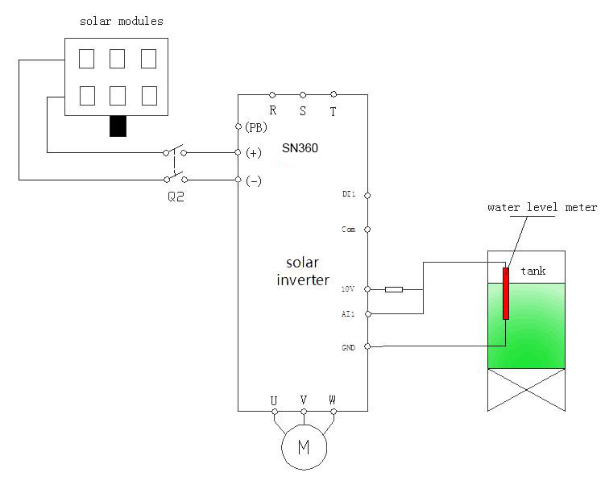

2. Set the motor parameters
- Set P17.01=1, and restore to the factory settings.
Set P17.01=2,restore to the factory settings(Include motor).
(b)Set P01.02=0, and change the command to keyboard control.
(c)Set the name plate of the motor,including:
P02.01(Motor’s rated power)
P02.04(Motor’s rated frequency)
P02.05(Motor’s rated speed(RPM))
P02.02(Motor’s rated voltage)
P02.03(Motor’s rated current)
<Remember to press”ENT”after setting>.

3. Detection of water yield for water pumps
Set the lower limit of output frequency P01.14=6.00Hz,stop mode P07.10=1,and coast to stop. And then,set P15.00=1 to enable the special function for water pumps,click “Run”and the default mode is MPPT,observe the running frequency and water yield. If the operation frequency or water yield is low at normal light, the motor wires may be reserved, so it is necessary to exchange the wiring.

4. PI adjustment to the water yield
If the user requires large or low water yield, it is necessary to adjust PI(P15.06～P15.10) properly. The bigger PI parameters, the stronger the effect is, but the frequency fluctuation of the motor is bigger, in reserve, the lower the water yield is, the more stable the motor frequency is.

5. Commissioning of MPPT speed tracking
P15.23 and P15.24 is the minimum and maximum voltage of the power tracking in MPPT mode. If the voltage range is smaller, the faster the tracking is. But the bus voltage in normal operation needs to be in the range, otherwise, the maximum power can NOT be tracked.

Generally:
(a) If the rated motor voltage is 415V,
P15.23=520(Minimum reference voltage),
P15.24=600(Maximum reference voltage).
(b) If the rated motor voltage is 380V,
P15.23=450(Minimum reference voltage),
P15.24=550(Maximum reference voltage).
(c) If the rated motor voltage is 220V,
P15.23=260(Minimum reference voltage),
P15.24=310(Maximum reference voltage).
Above settings are only for reference and can be adjust according to the actual applications or by automatic adjustment.
P15.26 is used to adjust the time between the maximum and minimum voltage of MPPT and can be used with P15.27 to adjust the maximum and minimum reference voltage. The upper limit of maximum reference voltage can NOT exceed the maximum setting value of P15.28.

- Fault setting and reset time setting of fault delay
If the pre-warning of weak light, full water and underload are needed, it’s necessary to set the detection point, delay time and reset time according to the actual working.
Full water/non water setting are P15.11～P15.14;
The function settings of underload are P15.16～P15.19;
The function setting of weak light are P15.20～P15.21.
Default settings can be used,too.

- Parameters setting after normal operation
When the normal amount of water, the system is stable after commissioning.
Then set P01.02 = 3, auto operation mode when power-on, and then set the ato operation delay time as P01.20 = 5, set the auto reset times P10.09 = 5, this mode as when power-on, after the delay time will run automatically, STOP key to stop, press the RUN key to continue.

Note: 85% of P10.62 corresponds to 460V. The coefficient can be modified,but can NOT be modified to below 65%(65% corresponds to undervoltage point 350v,so it may report undervoltage fault if the actual bus voltage is less than the value).

3-1-2.Commissioning steps during grid power supply
- Wire according to the diagram and check the wiring is correct or not.
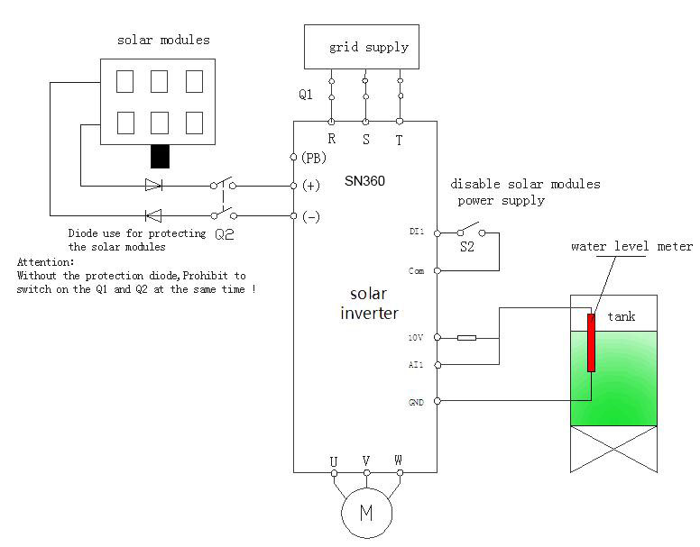

Now switch off Q2 and then switch on Q1 .
- After the power frequency, commission the system according to steps2、3、4、6 and 7 mentioned in 3-1-1.
- Set P05.00=53, and then switch on S2(or set P15.01=0)to enable the PV voltage reference.
Note: when use the back up supply, AC380V input connect with R/S/T, AC220V single phase input connect with R/T, AC220V 3-Phase input connect with R/S/T.
- When switch to PV power supply, Just need to switch off Q1 and S2, switch on Q2.
Note: If there is no diode protection at the bus input, Q2 and Q1 can NOT be switched on at the same time, otherwise, damage may occur to the buttery board.

Chapter 4 Faults and Solutions

4-1. Fault Information and Troubleshooting

SN360 provides a total of 50 items of fault information and protective functions. Once fault occurs ,the inverter implements protective functions,and stops the output,the inverter’s fault relay actions,and display the fault code on operation panel.
Before contacting manufacturer for technical support,you can first determind the fault type,analyze the causes and find the solutions.
If the troubleshootings belong to the types of the following diagram ,contact the agent or manufacturer for help.
E.Inv is the overvoltage or overcurrent signal of these 21 warning information items.In most situations, E.Inv is caused by hardware overvoltage.

Sequence | Fault code | Fault type | Possible causes | Solutions
1 | E.oUP | Inverter unit U  protection | 1、The output circuit short-circuited  2、The connecting cable of the motor is too long .  3、The module overheats  4、The internal connections  Becoming loose.  5、The main control board abnormal  6、Drive borad abnormal  7、The inveter module abnormal | 1、Eliminate external faults  2、Install a reactor or an output filter  3、Check the air filter and cooling fan  4、Connect all cables properly  5、Contact manufacturer for technical support  6、 Contact manufacturer for technical support  7、 Contact manufacturer for technical support
1 | E.oUP | Inverter unit V  protection
1 | E.oUP | Inverter unit W  protection
2 | E.oC1 | Overcurrent during  acceleration | 1、 The output circuit grouded or short-circuited 2、Control mode is VC,and the motor auto-turning is not performed  3、The acceleration time is too short  4、Manual torque boost and V/F curve is not appropriate  5、The voltage is too low  6、The startup operation is performed on the rotating motor  7、A sudden load is added during acceleration  8、The inverter model is of too small power class | 1、Eliminate external faults  2、Perform the motor auto-turning  3、Increase the acceleration time  4、Adjust the manul torque boost or V/F curve  5、Adjust the voltage to normal range  6、Select rotational speed tracking restart or start the motor after it stops  7、Remove the added load  8、Select an inverter of higher power class
3 | E.oC2 | Overcurrent during  deceleration | 1、The output circuit grouded or short-circuited  2、Control mode is VC,and the motor auto-turning is not performed  3、The deceleration time is too short  4、The voltage is too low  5、A sudden load is added during deceleration  6、The braking unit and braking resistor are not installed | 1、 Eliminate external faults  2、 Perform the motor auto-turning  3、Increase the deceleration time  4、Adjust the voltage to normal range  5、Remove the added load  6、Install the braking unit and braking resistor
4 | E.oC3 | Overcurrent at  constant speed | 1、The output circuit grouded or short-circuited  2、Control mode is SVC,and the motor auto-turning is not performed  3、The voltage is too low  4、A sudden load is added during deceleration  5、 The inverter model is of too small power class | 1、Eliminate external faults  2、Perform the motor auto-turning  3、Adjust the voltage to normal range  4、Remove the added load  5、Select an inverter of higher power class
5 | E.oU1 | Overvoltage during  acceleration | 1、The input voltage is too high  2、An external force drives the motor during acceleration  3、 The acceleration time is too short  4、 The braking unit and braking resistor are not installed | 1、Adjust the voltage to normal range  2、Cancel the external force or install a braking resistor  3、Increase the acceleration time  4、Install the braking unit and braking resistor
6 | E.oU2 | Overvoltage during  deceleration | 1、The input voltage is too high  2、An external force drives the motor during deceleration  3、The deceleration time is too short  4、The braking unit and braking resistor are not installed | 1、Adjust the voltage to normal range  2、Cancel the external force or install a braking resistor  3、Increase the deceleration time  4、Install the braking unit and braking resistor
7 | E.oU3 | Overvoltage at  constant speed | 1、 The input voltage is too high  2、An external force drives the motor during deceleration | 1、Adjust the voltage to normal range  2、Cancel the external force or install a braking resistor
8 | E.Br | Buffer resistor  overload fault | 1、The input voltage is not within the allowable range | 1、The input voltage is not within the allowable range
9 | E.LU | Undervoltage | 1、Instaneous power failure  2、The input voltage is not within the allowable range  3、The DC bus voltage is abnormal  4、The rectifier bridge and buffer resistor are abnormal  5、The drive board is abnormal  6、The control board is abnormal | 1、Reset the fault  2、Adjust the voltage to normal range  3、Contact manufacturer for technical support  4、Contact manufacturer for technical support  5、Contact manufacturer for technical support  6、Contact manufacturer for technical support
10 | E.oL1 | inverter overload | 1、The load is too heavy or locked-rotor occurs on the motor  2、The inverter model is of too small power class | 1、Reduce the load and check the motor and mechanical condition  2、Select an inverter of higher power class
11 | E.oL2 | Motor overload | 1, the motor protection parameters P10.01 setting is appropriate  2, the load is too large or the occurrence of motor stall  3, the inverter model is too small power class | 1, Setting correct parameters  2, Reduce the load and check the loading conditions  3, Select an inverter of higher power class.
12 | E.PHI | Input phase loss | 1、The 3-phase power input is abnormal  2、The drive board is abnormal  3、The lightening board is abnormal  4、The control board is abnormal | 1、Eliminate external faults  2、Contact manufacturer for technical support  3、Contact manufacturer for technical support  4、Contact manufacturer for technical support
13 | E.PHo | Output phase loss | 1、The cable connecting the inverter and motor is faulty  2、The inverter’s 3-phase outputs are unbalanced during the motor is running  3、The drive board is abnormal  4、The module is abnormal | 1、Eliminate external faults  2、Check whether the motor three-phase winding is normal  3、Contact manufacturer for technical support  4、Contact manufacturer for technical support
14 | E.oH1 | Module overheat | 1、The ambient temperature is too high  2、The air filter is blocked  3、The fan is damaged  4、The thermally sensitive resistor of the module is damaged  5、The inverter module is damaged | 1、Lower the ambient temperature  2、Clean the air filter  3、Replace the damaged fan  4、Replace the damaged  thermally sensitive resistor  5、Replace the inverter module
15 | E.SET | External equipment fault | 1、External fault signal is input via DI  2、 External fault signal is input via virtual I/0 | 1、Reset the operation  2、Reset the operation
16 | E.CE | Communication  fault | 1、The host computer is in abnormal state  2、The communication cable is abnormal  3、P00.28 set is improperly  4、The communication parameters in P14 are set improperly | 1、Check the cabling of the host computer  2、Check the communication cabling  3、Set the extension card parameters correctly  4、Set the communication parameters properly
17 | E.CoN | Contactor fault | 1、The drive board and power supply are abnormal  2、The contactor is abnormal | 1、The drive board and power supply are abnormal  2、The contactor is abnormal
18 | E.oCC | Current detection fault | 1.The connector of the control borad is not connect well  2.Auxiliary power fault  3.The HALL device fault  4.The amplify circuit is abnormal | 1．Check the connector  2．Contact manufacturer for  technical support  3．Contact manufacturer for  technical support  4．Contact manufacturer for  technical support
19 | E.TE | Motor auto-turning fault | 1.The capacity of motor and inverter are not match  2.The motor’s parametes are not set properly  3.The parameters between  auto-turning and standard are of big deviation  4．Auto-turning time out | 1．Replace the inverter model  2.Set the parameters according  to the motor nameplate  3.Auto-turning with the motor no-load  4. Check the motor cabling and parameter setting
20 | E.Enco | Encoder fault | 1、The encoder type is incorrect  2、The cable connection of encoder is incorrect  3、The encoder is damaged  4、PG card abnormal | 1、Set the encoder type correctly based on actual situation  2、Eliminate external fault  3、Replace the damaged encoder  4、Replace the PG card
21 | E.EEP | EEPROM R/W fault | 1.EEPROM chip is damaged | 1、Replace the control board
22 | E.INv | inverter hardware fault | 1、Overvoltage exsists  2、Overcurrent exsists | 1、Handle based on overvoltage  2、 Handle based on Overcurrent
23 | E.STG | Short circuit to ground | 1、The motor is short circuited to the ground | 1、Replace the cable or motor
26 | E.TIo | Accumulative running time reached fault | 1、 Accumulative running time reaches the setting value | 1、Clear the record through parameter initialization function
27 | E.USE1 | User-defined fault 1 | 1、 The user-defined fault 1 signal is input via DI  2、 The user-defined fault 1 signal is input via virtual IO | 1、Reset operation  2、Reset operation
28 | E.USE2 | User-defined fault 2 | 1 The user-defined fault 2 signal is input via DI  2、 The user-defined fault 1 signal is input via virtual IO | 1、Reset operation  2、Reset operation
29 | E.PUTO | Accumulative power-on time reached fault | 1、 Accumulative power-on time reaches the setting value | 1、Clear the record through parameter initialization function
30 | E.LOAD | Load lost fault | 1、The inverter’s running current is lower than P10.64 | 1、Make sure whether the load is connected or parameters of P10.64、P10.65 are correct
31 | E.PId | PID feedback  lost during  running | 1、PID is lower than the P11.26 setting value | 1、Check PID feedback signal or set P11.26 to a proper value
40 | E.CBC | Pulse by pulse  current limit  fault | 1、The load is too heavy or locked-rotor occurs on the motor  2、The inverter is of too small power class | 1、 Reduce the load and check the motor and mechanical condition  2、Select an inverter of higher power class
41 | E.SrUN | Motor switchover fault during running | 1、Change the selection of the motor via terminal during running of the inverter | 1、Perform motor switchover after inverter stops.
42 | E.SSD | Too large speed deviation fault | 1、The encoder parameters are set improperly  2、The motor auto-turning is not performed  3、P10.69 and P10.60 are set incorrectly | 1、Set the encoder parameters properly  2、Perform the motor auto-turning  3、Set P10.69 and P10.60 correctly based on actual situation
43 | E.oS | Motor over-speed fault | 1、The encoder parameters are set incorrectly  2、The motor auto-turning is not performed  3、P10.69 and P10.60 are set incorrectly | 1、 Set the encoder parameters properly  2、 Perform the motor auto-turning.  3、 Set P10.69 and P10.60 correctly based on actual situation
44 | E.oH2 | Motor overheat fault | 1、The cabling of temperature sensor becomes loose  2、The temperature of motor is too high | 1、Check the temperature sensor cabling and eliminate the cabling fault  2、Lower the carrier frequency or adopt other heat radiation measures.
45 | E.INIT | Initial position fault | 1、The motor parameters are of large deviation of the actual . | 1、Check that the motor parameters are set correctly and whether the setting of rated motor current is too small
46 | E.Load | Electronic underload fault | The inverter will report the underload pre-alarm according to the set value | Check the load and the underload pre-alarm point.
47 | E.tSF | Hydraulic probe damage | Hydraulic probe damage and the feedback signal wire are not connected well. | Check the wiring and change the probe.
48 | A-LS | Weak light  Pre-warning | The output frequency is lower than or equal to the lower limit of PI output frequency and keep to reach to the weak light delay time. | Check the lower limit of PI output and the setting value of delay time.
49 | A-LL | Underload  pre-warning | The water pump runs at a small load and the operation time reaches the set time. | Check the water level of the resource and the pre-warning point of underload.
50 | A-tF | Full-water  pre-warning | The feedbacked water leve is lower than the threshold and keep it for a certain time. | Check the pre-warning point of the water level.

4-2. Common Faults and Solutions
You may come across the following faults during the use of the inverter,refer to the following table for simple fault analysis:

1 | There is no display at power-on | There is no power supply to inverter or the power input to inverter is too low；  The power supply of the drive board of AC dirve is faulty；  The rectifier bridge is damaged；  The buffer-resistor of the inverter is damaged；  The control board and the operation panel are faulty；  The cabling between control board and drive board and operation panel breaks ； | Check the input power supply；  Check the DC bus voltage；  Re-connect the 8-core or 28-core cables.  Contact manufacturer for technical support；
2 | SN360 is displayed at power-on | The cable between control board and drive board is in poor contact；  Related components of the control board are damaged；  Re-connect the 8-core or 28-core cable ；  The motor or the motor cable is short-circuited to ground；  Contact manufacturer for technical support；  The HALL device is faulty ；  The power input to the inverter is too low；
3 | “E.STG”is displayed at  power-on | The motor or the motor cable is short-circuited to ground；  The inverter is damaged； | Measure the insulation of the motor and the motor output cable with a Megger；Contact manufacturer for technical support；
4 | The inverter display  is normal .But SN360 is displayed after running and stops immediately | The cooling fan is damaged or locked-rotor occurs；  The external control terminal cable is short circuited； | Replace the cooling fan ；  Eliminate the external short circuited fault ；
5 | E.oH1(module overheat) fault is reported frequency | The setting of carrier frequency is too high.  Lower the setting of the  carrier frequency(P01.15).  The cooling fan is damaged or locked-rotor occurs.  Replace the cooling fan and clean the air filter .  Components inside inverter are damaged(Thermal coupler or others)  The motor and the motor cabling；  The setting parameters of the inverter is faulty(The motor parameters )；
6 | The motor does not rotate after the inverter runs | The motor and the motor cabling；  The setting parameters of the inverter is faulty(The motor parameters)；  The cable between control board and drive board is in poor contact；  The control board is faulty； | Ensure the cable between the inverter and motor is normal；  Replace the motor and clear the mechanical faults ；  Check the reset motor parameters ；
7 | DI terminals are invalid | The parameters are set incorrectly；  External signals is incorrect；  The jump bar between OP and +24V becomes loose；  The control board is faulty； | Check and reset the corresponding parameters of P05 group；  Re-connect the external signal cable；  Ensure the jump bar between OP and +24V；  Contact manufacturer for technical support；
8 | The motor speed is always low in CLVC control mode | The encoder is faulty；  The encoder cable is connected incorrectly or in poor contact；  The PG card is faulty；  The control board is faulty； | Replace the encoder and ensure the cable connect properly；  Replace the PG card；  Contact manufacturer for technical support；
9 | Replace the encoder and reconfirm the wiring;  Replace PG card;  Seeking services; | The motor parameters are set improperly；  The acceleration /deceleration time is improper；  The load fluctuates； | Reset the motor parameters or perform the motor auto-turning；  Set the proper acceleration /deceleration time；  Contact manufacturer for technical support；
10 | E.CoN is reported upon power-on or running | The soft startup contactor is not picked up | Check whether the contactor cable is loose；  Check whether the contactor is faulty；  Check whether 24V power supply of the contactor is faulty；  Contact manufacturer for technical support；
11 | “88888” is displayed upon power-on | Related components of control board are damaged； | Replace the control board

Chapter 5 Recommended solar panels
SN360-037D-3 | SN360-030D-3 | SN360-022D-3 | SN360-018D-3 | SN360-015D-3B | SN360-011D-3B | SN360-7R5D-3B | SN360-5R5D-3B | SN360-004D-3B | SN360-003D-3B | SN360-2R2D-3B | SN360-1R5D-3B | SN360-0R7D-3B | Inverter Model
120.3 | 97.6 | 71.5 | 58.6 | 49.0 | 39.2 | 30.6 | 23.9 | 16.5 | 9.6 | 7.1 | 6.1 | 4.2 | (A) | Max.DC input current (A)
 |  |  |  |  |  |  |  | 85 | 60 | 90 | 60 | 30 | Panels power  ±5Wp | 20±3V | Open-circuit voltage degree of solar panels
 |  |  |  |  |  |  |  | 28*2 | 30*2 | 30*1 | 30*1 | 29*1 | Panels per  string* strings | 20±3V | Open-circuit voltage degree of solar panels
 |  |  | 200 | 205 | 200 | 215 |  | 220 |  |  |  |  | Panels power  ±5Wp | 30±3V | Open-circuit voltage degree of solar panels
 |  |  | 27*4 | 22*4 | 22*3 | 21*2 |  | 22*1 |  |  |  |  | Panels per  string* strings | 30±3V | Open-circuit voltage degree of solar panels
 | 200 | 200 | 200 | 200 | 195 | 175 | 195 | 140 | 195 | 145 |  |  | Panels power  ±5Wp | 36±3V | Open-circuit voltage degree of solar panels
 | 18*10 | 18*8 | 18*6 | 18*5 | 17*4 | 17*3 | 17*2 | 17*2 | 17*1 | 18*1 |  |  | Panels per  string* strings | 36±3V | Open-circuit voltage degree of solar panels
240 | 240 | 220 | 240 | 240 | 220 | 200 | 220 | 160 | 220 | 175 |  |  | Panels power  ±5Wp | 42±3V | Open-circuit voltage degree of solar panels
15*12 | 15*10 | 15*8 | 15*6 | 15*5 | 15*4 | 15*3 | 15*2 | 15*2 | 15*1 | 15*1 |  |  | Panels per  string* strings | 42±3V | Open-circuit voltage degree of solar panels
300 | 300 | 300 | 300 | 300 |  | 300 |  |  |  |  |  |  | Panels power  ±5Wp | 42±3V | Open-circuit voltage degree of solar panels
15*8 | 15*8 | 15*6 | 12*6 | 15*4 |  | 15*2 |  |  |  |  |  |  | Panels per  string* strings | 42±3V | Open-circuit voltage degree of solar panels

